Application Deployment using RENDER Platform:
- React → frontend
- Express.js → backend middleware
- MongoDB Atlas → cloud database
Below is a complete project structure and working code you can copy-paste to run.
Project code Github URL: https://github.com/lakshminarayana-kodavali/MERN-KLN-PROJECT.git
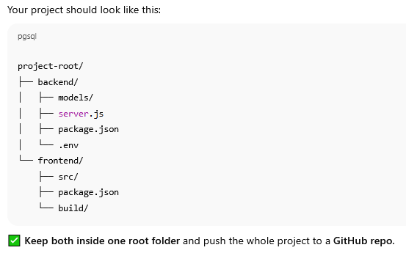
NOTE: Build folder in frontend project will create automatically during deployment.

Modify Your Backend for Deployment

📄 backend/server.js
Replace your existing code with this modified version
(You only need to update this one file.)
============================================
const express = require("express");
const mongoose = require("mongoose");
const cors = require("cors");
const dotenv = require("dotenv");
const bcrypt = require("bcryptjs");
const path = require("path");
const User = require("./models/User");

dotenv.config();
const app = express();

app.use(cors());
app.use(express.json());

// ✅ Connect MongoDB
mongoose
.connect(process.env.MONGO_URI)
.then(() => console.log("✅ MongoDB Connected"))
.catch((err) => console.log(err));

// ✅ Signup Route
app.post("/signup", async (req, res) => {
const { name, email, password } = req.body;
const userExists = await User.findOne({ email });
if (userExists) return res.status(400).json({ msg: "User already exists" });

const hashedPassword = await bcrypt.hash(password, 10);
const user = new User({ name, email, password: hashedPassword });
await user.save();
res.json({ msg: "User registered successfully" });
});

// ✅ Login Route
app.post("/login", async (req, res) => {
const { email, password } = req.body;
const user = await User.findOne({ email });
if (!user) return res.status(400).json({ msg: "User not found" });

const isMatch = await bcrypt.compare(password, user.password);
if (!isMatch) return res.status(400).json({ msg: "Invalid credentials" });

res.json({ msg: "Login successful", user });
});

// ✅ Serve frontend build files after building React app
app.use(express.static(path.join(__dirname, "../frontend/build")));

app.get("*", (req, res) => {
res.sendFile(path.join(__dirname, "../frontend/build", "index.html"));
});

const PORT = process.env.PORT || 5000;
app.listen(PORT, () => console.log(`🚀 Server running on port ${PORT}`));

=====================================================================

Modify Frontend API Base URL
In your frontend/src/api.js file, replace entire code like this:
import axios from 'axios';

const api = axios.create({
baseURL: "/", // ✅ relative URL — works for both local & Render
});

export default api;

Add Build Script in Backend
In your backend/package.json, update this section, with build command:
"scripts": {
"start": "node server.js",
"dev": "nodemon server.js",
"build": "cd ../frontend && npm install && npm run build"
}

Local output:
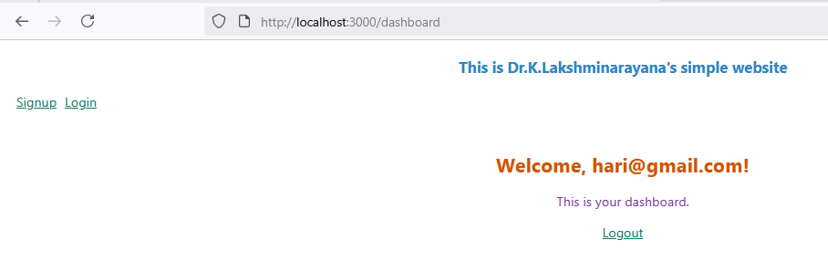

Push to GitHub
Make sure your folder structure is like this:
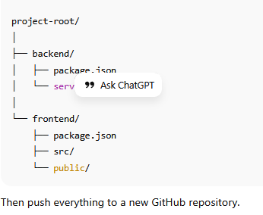
Push Commands
git init
git add .
git commit -m "first commit"
git branch -M main
git remote add origin https://github.com/lakshminarayana-kodavali/MERN-KLN-PROJECT.git
git push -u origin main

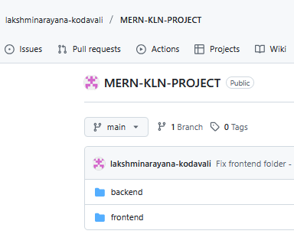

Deploy Process on Render
- Go to https://render.com
- • Log in with GitHub.
- • Click "New Web Service" → Connect your repo.
- • In setup page, set these options:
- Setting | Value

Root Directory | backend

Build Command | npm install && npm run build

Start Command | node server.js

Environment Variables | (add below)

Add environment variables:
MONGO_URI = your-mongodb-atlas-uri
JWT_SECRET = anysecretkey
PORT = 5000
Click Deploy Web Service.
Render will:
- install dependencies,
- build your React app,
- start your Express server,
- serve React from /frontend/build.
Update Later (Auto Deployment)
Login into Render for deployment:
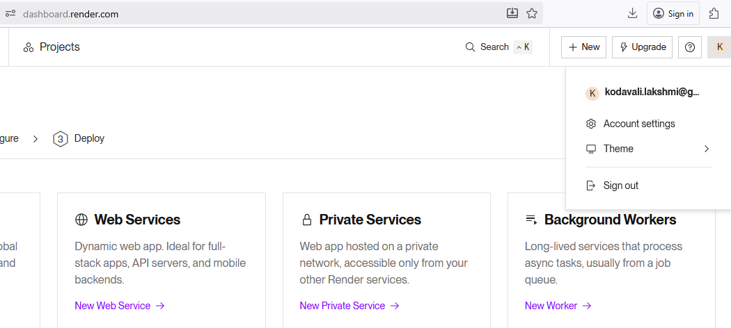
Click on “New Web Service”
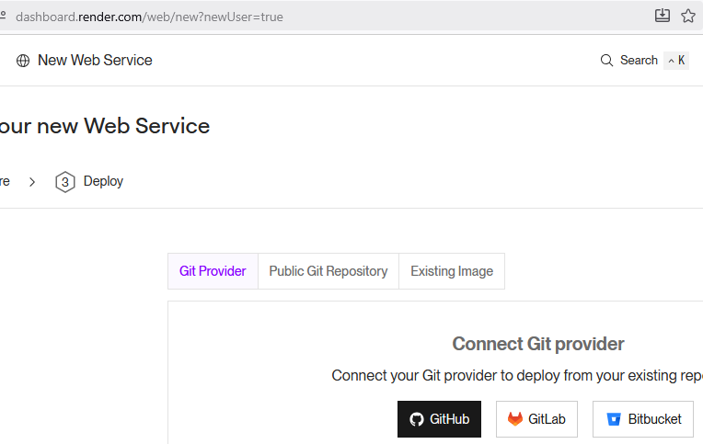
Connect with HitHub and Select the project repository

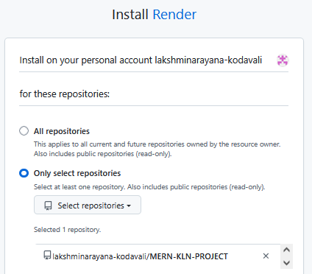
Setting Values
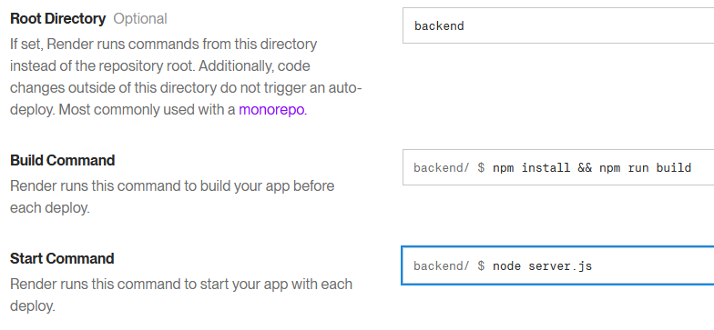
Select Instance type: FREE
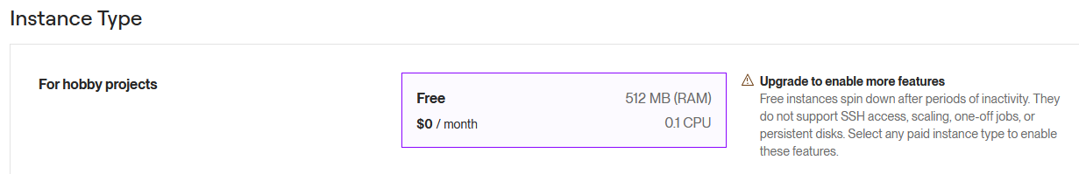
Add environment variables:

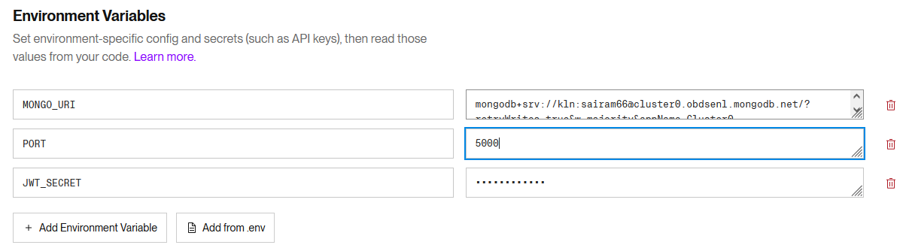

Click on “Deploy Web Service”
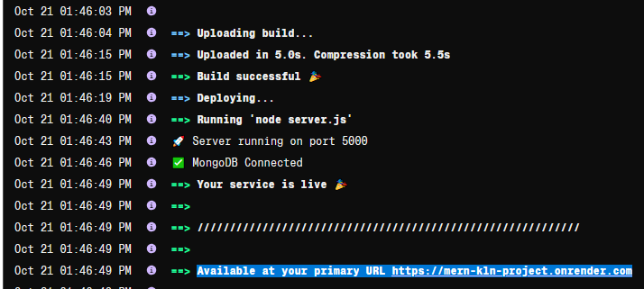

Deployment link is Available at your primary URL: https://mern-kln-project.onrender.com
I accessed the above project through my mobile and signup and signin with one record (Dohathi) successfully.
Login into mongodb atlas Cloud to check my database update https://www.mongodb.com/cloud/atlas
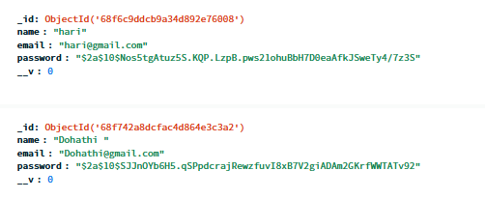
Database successfully updated with Dohathi record.

